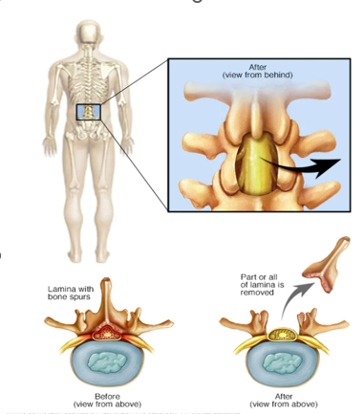
Instructions for a Laminectomy:
A surgeon will remove a piece of bone from the back of your spine called the lamina. This procedure is called laminectomy. Its purpose is to relieve the pressure caused by a bulging disk, ligament, cyst, tumor, or bone that painfully pushes on a nerve.
Pre – Op
One Week before
- Be sure to stop taking your blood thinners (ie: aspirin, ibuprofen, Advil, Aleve, etc.) If you are on medications such as Warfarin, Pradaxa, Eliquis, Plavix, be sure you talk with your surgeon.
- Have someone remove electrical cords, throw rugs, and anything else in your home that may cause you to trip and fall.
- Arrange your household to keep items you need handy and in a convenient spot.
Day before
- NPO, nothing to eat after midnight the day before your procedure.
- Chlorhexidine Gluconate (CHG bath) - the morning of the surgery. Please follow the instructions given at your pre-op appointment at TGH.
Discharge Instructions for Laminectomy
Activity
- No BLT’s, No bending, lifting or twisting until cleared by our doctor. Use a long-handled "grabber" to pick items up from the floor. You can also use an assistive device to help pull on your socks without bending. Ask your physical therapist about these items before you leave the hospital.
- Do not sit for more than 20 to 30 minutes at a time. And when you aren’t sitting, lie down or walk.
- Walk as much as you can. Moving around will help your blood circulation and can prevent constipation. You can walk outside or inside. If you use a treadmill, walk at a slow speed, with no incline. (number of times a day)
- Going up and down stairs is also good for you, so do it as much as possible. Don’t lift anything heavier than 10 pounds (ie: a gallon of milk) until your healthcare provider says otherwise.
- Don’t drive for 2 to 3 weeks after your surgery. And never drive if you are taking opioids or other pain medicines that can make you drowsy. Let others drive you instead. And limit car trips to 20 to 30 minutes at a time.
Home care
Medications:
- Take your medicine exactly as directed by your healthcare provider.
- Do not take any NSAIDS (ex: Motrin, Aleve, Ibuprofen, Advil, Mobic) until cleared by your surgeon.
- Over-the-counter stool softener or laxative as needed (examples: Colace, Miralax, Dulcolax. Ask your pharmacist to assist).
Diet:
- You may resume your regular diet.
Wound Care:
- Leave the incision open to air
- You may Shower 24-48 hours after surgery, clean the incision with soap and WATER only.
- Check your incision daily for redness, tenderness, and drainage.
- Do not soak in a bathtub, hot tub, or pool until cleared by your doctor.

Bowel Management: Pain Medications are constipating, so while on these medications:

- Increase high fiber foods, such as apples, peaches, prunes, apricots, oatmeal, and vegetables of your choice. Always drink 8-10 glasses of water daily when adding fiber to your diet.
- Take a stool softener such as Colace 1-2 times daily while taking pain medications. If your stool is loose or watery then skip the stool softener.
- If you have not had a bowel movement in 48 hours, add a laxative as well, such as Senna, MiraLAX, Fleets enema or Dulcolax suppository and repeat doses per package instructions until you have had a Bowel Movement.

Follow-up
- Make an appointment to have sutures or staples removed about 2 weeks after surgery.
POST OP appointment: _____________________________________

Call 911 right away if you have any of the following:
- Chest pain
- Shortness of breath
- A severe headache
- Trouble controlling your bowels or bladder
- Calf that is painful, warm to the touch, and tender with pressure

When to call USF Neurosurgery 813-821-8034
- Pain, increased redness, or foul-smelling drainage from the incision that gets worse
- If your incision opens
- Fever of 100.4° F ( 38°C) or higher, or as directed by your healthcare provider
- Shaking chills
- New pain, weakness, warmth, or numbness in your legs
- Foot, ankle, or calf swelling that does not get better after elevating your feet

USF Tampa Location
MyChart please contact. If you do not have a mychart account, please call.

