In New Innovations, nurses can check the procedure credentials of residents and fellows. Most of the privileges shown apply to bedside procedures. For surgical procedures, please click here to review the program’s scope of practice document. Begin by:

- Using the Internet, go to https://www.new-innov.com/Login/Login.aspx.
- Enter the following information and then click the Log In button.
Institution: USF
Username: nurse
Password: nurse
- In the Procedure Search module, you are able to search by typing in:
Last Name OR Procedure Name
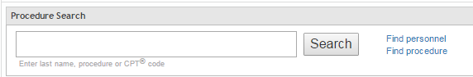

Results Page for Searching by Last Name
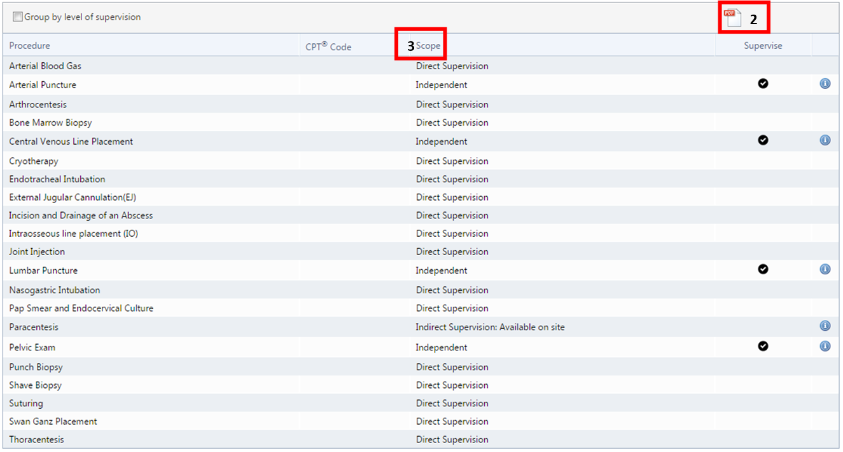
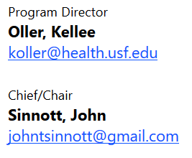

1

2  1 | Header Section – provides trainee’s program & contact information  PDF Icon – creates a PDF copy of that resident’s Privilege Report | 3 | Scope – indicates the trainee’s level of supervision. This can vary from procedure to procedure.

Please click this link to provide feedback on a trainee: https://hsccf.hsc.usf.edu/residents/professionalism/

